Paper Title for Manuscripts Preparation (Paper Title Style)
First Author¹, Second Author^{2*}, Third Author³ (Author Style)
¹ Chemical Education, Lampung University, Bandar Lampung, 35145, Lampung, Indonesia
² Physics Department, Lampung University, Bandar Lampung, 35145, Lampung, Indonesia
³ Agrotechnology, University of Lampung, Bandar Lampung, 35145, Lampung, Indonesia (Affiliation Style)

ABSTRACT |  | ARTICLE INFO
The instruction for the preparation of the full manuscript is detailed in this template file. The template is intended as a tool to assist you in the layout of your manuscript. It is encouraged that this template can be used for submission of manuscripts. Use of the template will save time during production and expedite publication. (Abstract Style) |  | Received: xxxxxxxxx  Accepted: xxxxxxxxx  Published: xxxxxxxxx
KEYWORDS
Keyword1, keyword2, keyword3, keyword4, keyword5

INTRODUCTION (Section Style)
The introduction shows what is already known from the previous studies, defines the importance of the study, literature review, and the research objectives.
In order to understand what is already known from the previous studies, the introduction must consist of discussions of relevant journal articles (with citations) and a summary of the current understanding of the problem to show novelty of the research.

LITERATURE REVIEW
This section consists surveys books, scholarly articles, and any other sources relevant to a particular issue, area of research, or theory, and by so doing, provides a description, summary, and critical evaluation of these works in relation to the research problem being investigated.

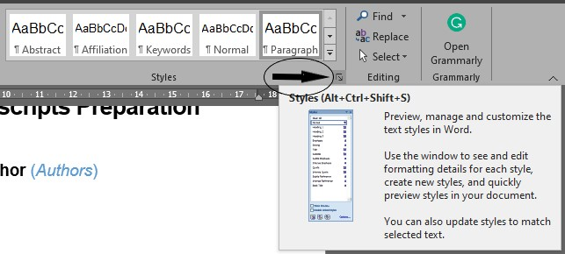
Figure 1. Show the styles window (Figure Caption Style)

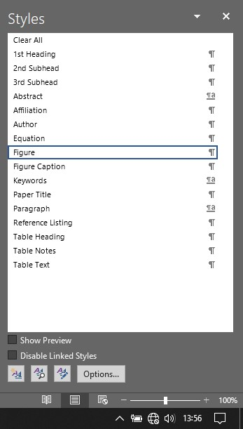 (Figure Style)
Figure 2. Change style → style menu

METHODS
The methods explain clearly how the author carried out the research. The method must describe the research design clearly, the replicable research procedures, describe how to summarize, and analyze the data.

Participants (Heading 2)

Instruments (Heading 2)

Data analysis (Heading 2)
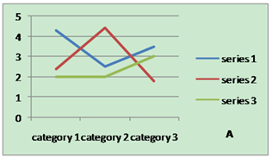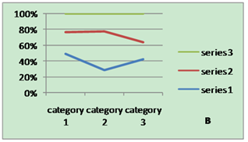
Figure 3. Data category

Table 1. Specific data of column/row (Table Heading Style)
Number (Table Text Style + Bold) | Column Header 1 | Column Header 2
Row Header 1 (Table Text Style) | X (Table Text Style) | X (Table Text Style)
Row Header 2 | X | X
Row Header 3 | X | X

The equation number should be placed in parentheses to the right of the equation. Do not create equations as pictures. Use MathType or insert symbols as normal text.
Equation as normal text:
E=MC²$\sin{α}±\sin{β}=2\sin{\frac{1}{2}\left(α±β\right)}\cos{\frac{1}{2}\left(α∓β\right)}$ (Equation Style) (1)
Equation created by MathType:
(2)

RESULTS
The result section shows objectively the presentation of the research key result without any interpretation using text, tables and figures. The result section must present how the author ensure the data validity and reliability. The results should be clear and concise.

DISCUSSION
The discussion section shows how the author interprets the results in light of what was already known, and to explain the new understanding of the problem after taking the results into consideration. The discussion must connect with the Introduction so it tells how your study contributes to the body of knowledge and society.

CONCLUSION
The conclusions and suggestions section shows the answers or clarification of research questions, implications, and opportunities for future research by giving relevant suggestions.

ACKNOWLEDGEMENTS
The purpose of the acknowledgements section is to thank all of the people who helped with the research but did not qualify for authorship. Acknowledge anyone who provided intellectual assistance, technical help (including with writing and editing), or special equipment or materials.

FUNDING
Authors are required to specify any sources of funding (institutional, private and corporate financial support) for the work reported in their paper. This information, in the form of the name of the funding organisation/s and the grant number -or should be included at the end of the article under the heading ‘Funding’, and provided at the time of submitting the paper. If there was no funding, the following wording should be used: “This research received no specific grant from any funding agency in the public, commercial, or not-for-profit sectors.”

REFERENCES
The reference must be written in APA style 7th edition (below are the examples). When writing the reference list, please write alphabethically, and use the following conventions (To find out further information please visit https://apastyle.apa.org/).

Anuwong, C., Ohtake, N., Sueyoshi, K., Ruamrungsri, S., & Ohyama, T. (2014). Characterisation of proteins in the storage organs of Curcuma alismatifolia Gagnep. The Journal of Horticultural Science and Biotechnology, 89(5), 501–507. https://doi.org/10.1080/14620316.2014.11513112
Blok, L. G., Longana, M. L., Yu, H., & Woods, B. K. S. (2018). An investigation into 3D printing of fibre reinforced thermoplastic composites. Additive Manufacturing, 22(May), 176–186. https://doi.org/10.1016/j.addma.2018.04.039
Nobili, A., & Pichugin, A. V. (2021). Quasi-adiabatic approximation for thermoelastic surface waves in orthorhombic solids. International Journal of Engineering Science, 161. https://doi.org/10.1016/j.ijengsci.2021.103464
Rajabifard, A., Foliente, G., & Paez, D. (2021). COVID-19 pandemic, geospatial information, and community resilience (1st ed., pp. 1–558). CRC Press. https://doi.org/10.1201/9781003181590
She, L. F., Xia, Y. P., Chang, L., Xiao, Y. M., Ren, Z. M., & Zhang, L. (2014). Biochemical and physiological responses of bulblets of Lycoris aurea to exogenously applied N-(2-chloro-4-pyridyl)-N1-phenylurea. The Journal of Horticultural Science and Biotechnology, 89(5), 549–556. https://doi.org/10.1080/14620316.2014.11513119
Wood, A. M. (2000). Tunnelling (1st ed.). CRC Press. https://doi.org/10.4324/9780203477663

